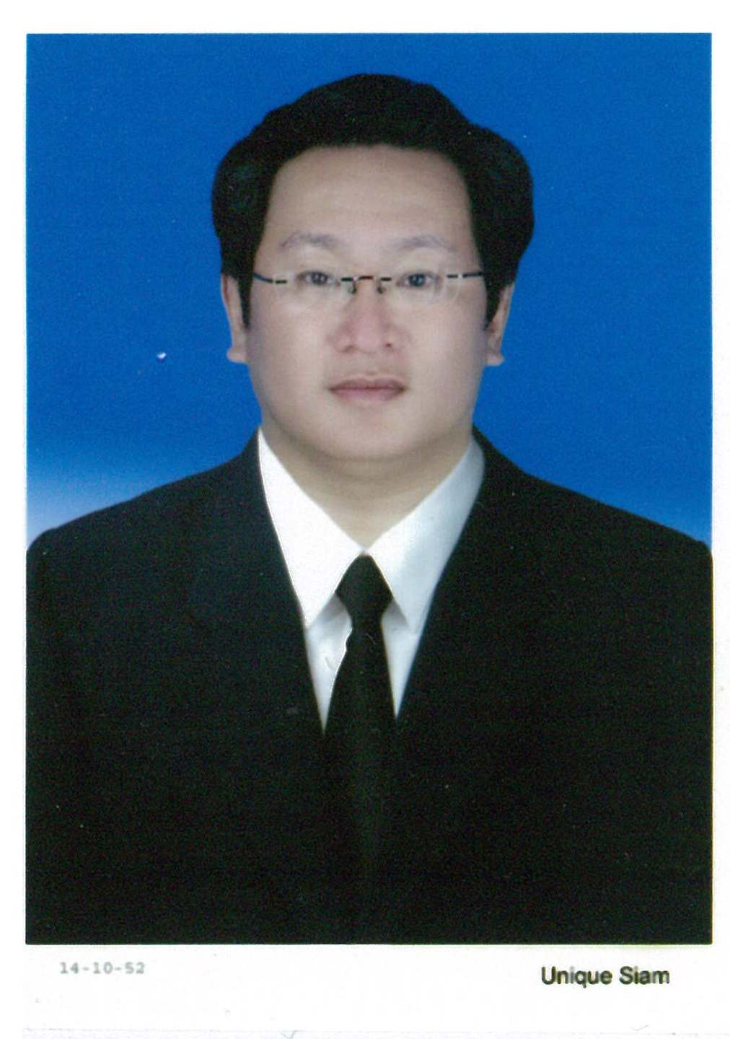
Chandhaluk Heesawat (Ph. D.)
ดร. ฉันทลักขณ์ ฮีสวัสดิ์

Expected Package: Negotiable
Available Upon 30-Day Notice

Current Package
- Monthly Salary THB 150,000
- Company Car: Toyota Camry
- Gasoline: As occurred
- Bonus: Flexible (Depending on company profitability)
- Mobile Allowance THB 5,000

Current Address
421/59 Lumpini Place Water Cliff, D Building, 15th Floor, Room 59, Sathupadit Road, Chongnonsi, Yannawa, Bangkok 10120
Cell Phone: 0860207997 e-mail address: bp3905@yahoo.com

Gender: Male Height: 165 cms.
Weight: 72 kgs. Date of Birth: January 10th, 1971

Educational Background
2002-2005 King’s International University of Science and Technology Delaware, USA.
- Ph. D. In Business Administration
- Doing a thesis titled “Supply Chain Integration and Competitiveness of the Thai Automobile Industry”
- Full tuition and allowance paid by King’s International University of Science and Technology
2002-2004 Assumption University Bangkok, Thailand
- Postgraduate Diploma in Teacher Education
1993-1994 Assumption University Bangkok, Thailand
- Master of Science in Computer Engineering Management (Msc., CEM)
- Full tuition and allowances paid by Assumption University
1989-1992 Assumption University Bangkok, Thailand
- Bachelor’s Degree in Business Administration, majoring in General Management (BBA in General Management)
- Graduated with first-class honor, GPA. = 3.85

Work Experience
November, 2009-Now Intelligence Content and Media General Manager
- Directly reports to the Managing Director
- Works with clients (including PTT and Unilever) to uncover business needs and objectives, crafts appropriate strategies, and identifies/implements necessary vehicles to drive clients towards goal achievement
- Approaches include traditional media communications as well as social media and viral marketing
- Develops a deep understanding of the client’s business (going beyond CRM and marketing), ensuring a clear understanding of the impact of key business issues on program priorities
- Works with the business development team to develop new client sales proposals
- Leads a team of fifteen marketing professionals
- Ensures resources and opportunities are available for the account teams to gain required skills and abilities
- Monitors workflow across account teams to ensure efficient delegation of projects; fosters teamwork and a constructive work environment
- Assumes a leading role in the reviews and evaluations of the quality of the agency’s products for all major creative, media, strategic and marketing strategies at the critical stages of their development, presentation and implementation
- Manages the overall client/account P&L, ensuring responsible financial management and delivery of account profit expectations
- Manages budgets and delivers programs within projected costs, including developing detailed marketing program cost estimates, business cases, and ROI models.
- Analyses financial statements and presents financial justification for strategic recommendations
Key Achievements
- Initiate and implement the “Digital Signage” Projects, the LCD’s installed in 147 PTT Jiffy Gas Stations all over Thailand. Projects finished within budgetary constraints 8 months before originally scheduled
- Initiate and implement the once-a-week, one-hour “CSR TV Program” on Thai PBS Channel. The program provides major companies with a platform to promote their charitable & CSR activities. It will also praise the community leaders for their contributions to the community and those organizations
June, 2007-October, 2009 Siam City Cement Public Company Limited
Integrated Communications Manager
- Reported to the Senior Vice President of Marketing and Sales
- Directed the firm's marketing and customer communications programs including public relations, media relations, copywriting, graphic design, collateral materials, direct mail, web site content and corporate identity program
- Maintained relationships with both government entities and the media
- Oversaw marketing and communications campaigns for companies in the group (Siam City Concrete, Geocycle, and CONWOOD)
- Reached / exceeded budgeted financial goals across the company’s key customer retention categories - saves and reinstatement, customer longevity, load ups, and cross sell - using a variety of communication media
- Conceptualized and managed a diverse range of customer retention campaigns and initiatives. These included idea generation and exploration, preparing and presenting proposals, overseeing the creative and production processes and championing successful execution
- Analyzed CRM campaign outcomes in detail, using a variety of proprietary software applications. Drew insights and presented results clearly to facilitate sound decision-making on next steps
- Assisted in the creation of customer demand through branding
- Participated in a variety of special projects as requested, including explorations of system or process improvements, new retention categories, and joint projects with Customer Service
- Worked with Customer Service, Marketing Services and Operations to develop and maintain a customer-focused attitude toward activities, concentrating on those that most strongly contribute toward improving customer lifetime value
Key Achievements:
- Increased Brand Equity Index (BEI) of INSEE brand from 2.7 in 2007 to 3.4 in 2008, 20% above the planned target one year ahead of time
- Helped decrease spending on Marketing Communication by more than THB 30 Millions in 2008
- Created PR value more than THB 10 millions through media relations
- Planned and designed “Advertorial”, “Informercial” and use “viral marketing” to change the face of INSEE advertising
- Wrote the marketing parts in the 2008 Annual Report with various stakeholders as target groups
- In collaboration with HR, contributed in the creation of “Marketing for Non-marketers”, a training designed to internally implanting marketing knowledge and communicating the achievements of Customer Management Department to other work units rather than Marketing

April 2003 -May 2007 Central Retail Corporation Ltd.
General Manager- CRM management
- Reported to the Senior Vice President of Marketing and Sales
- Technical responsibility for implementation and database management, as well as overall responsibility for The 1 Card marketing campaigns
- Developed CRM Programs with an overall objective of delivering incremental sales volume and supporting customer satisfaction and customer retention
- Established and managed customer satisfaction survey projects as well as CRM projects and client database management
- Managed the CRM and its reporting systems, as well its structures
- Provided analyses in terms of sales figures as well as customer behaviors by segment; suggested defensive and offensive strategies to generate new business opportunities, as well as marketing propositions to both acquire and retain customers
- Worked closely with the MIS, Marketing and Research teams
- Analyzed and developed CRM strategy programs in the form of discounting, points collection and special events (The 1 Card Bonus, Birthday Card, Thank You Party)
- Launched exclusive promotional program (The Gold Value package program) to help retain existing customers and Happy Hour discount program to drive sales
- Led direct marketing campaigns (primarily surface mail, but also including SMS and email)
- Strengthened the value proposition in terms of benefit and privilege by consistently offering exclusive benefits and privilege to members in all promotion campaigns
- Managed change requests and prompt data adjustment during each stage of CRM project. Developed reporting systems and updated member spending behavior and insights with merchandising and operation.
- Coordinated and participated with other functions such operations and merchandisers to ensure that each project was successfully implemented.
- Engaged with Central’s suppliers to gain participation in enhanced rewards campaigns, as well as negotiating discounts on unit prices from these suppliers
- Used evidence-based selling to clients, whilst ensuring the promotion would be in line with the client’s overall marketing campaign
- Initiated strategic alliance approach to acquire and closely work with strong partners such as Nokia, LG, DTAC, SCB in the corporate promotion program
- Conducted and reviewed market research to anticipate competition and market trends and translate consumer attitudes into branding directions
- Led a team of 8-10 people, including both Analysts and Product Specialists

Key Achievements
- Initiate strategic alliance approach to acquire and closely work with strong partners such as Nokia, LG, DTAC, SCB in the corporate promotion program
- Conduct and review market research to anticipate competition and market trends and translate consumer attitudes into branding directions

Nov. 2000 – April 2003 Colgate Palmolive-Thailand Limited
Group Brand Manager: Dental Hygiene Products
- Reported to Marketing and Sales Director
- Strengthened brand equity among consumers, dentists, and other influencers
- Increased brand competitiveness via moving production line from the U.S. to Thailand (Thailand is now the sourcing country for the ASEAN region)
- Worked closely with buyers on sales, promotion, event & shop display
- Rolled out new Colgate products such as Colgate Total, Colgate Plax
- Assisted research agencies in the selection of the most appropriate research methodology and techniques, the design of qualitative and quantitative research plans for products in all stages of the Product Life Cycle, and the design of research questionnaires and moderator discussion guides
- Supervised, and organized training and seminars to dealers and teams
- Led/coached the team in managing, developing relationships and selling to targeted channel partners and customers
- Co-ordinated with the team to develop marketing plans
- Assisted National Sales Manager to develop the sales strategy beneficial to the company’s stakeholders to ensure long-term business partnership
- Coached the team to build and foster close relationship with the trade to build up long term business relationship
- Coordinated to input feedbacks from the field and market intelligence; new opportunities and competitors' activities to increase company’s competency
- Led a team of four brand managers (covering each of the four Dental Hygiene categories - toothbrush, mouthwash, floss, toothpaste)
Key Achievements
- Set up SBU, revised business pattern & operations for Colgate
- Create brand upside plan that significantly expanded business size

November, 1998 – Oct., 2000 Johnson & Johnson (Thailand) Limited
Senior Brand Manager: Acuvue
- Reported to Marketing Director
- Responsible for overall brand health & performance
- Led the development of the Brand Marketing Plan, following the Group category plan guidelines to meet national brand strategy
- Build productive working relationship with Sales, regional category team, Finance and Supply Chain to manage the brand’s day to day operations, and external partners and agencies
- Identified customer and channel category trends, supply chain and financial  implications and emerging consumer and shopper behavior
- Determined brand and customer fit behind category value drivers
- Led integrated Marketing Plan development and deployment
- Responsible for the brand P&L & profitability of the brand
- Provided input to volume forecasting, financial updates and monitoring of key indicators / drivers of brand performance. Recommended solutions and implemented improvements to meet annual targets
- Responsible for launch management; building launch plans, customer sell-in and legal & regulatory issues
- Assisted research agencies in the selection of the most appropriate research methodology and techniques, the design of qualitative and quantitative research plans for products in all stages of the Product Life Cycle, and the design of research questionnaires and moderator guides
- Built strong relationships with a range of key modern trade outlets including Boots, Watsons and others

Key Achievements
- Grow business by 20% from previous year, and market share by 3 points (record growth) within one year through excellent marketing plan

April, 1994-October, 1998 Grammy Entertainment Public Company Limited
Business Development Manager
- Reported to Business Development Director
- Developed marketing strategies to ensure direct customer contact
- Prepared sales presentations and/or contracts for products or services
- Prepared marketing reports and/or call reports as required to indicate activity and historical data
- Responsible for creating and developing new business streams especially in terms of international business
- Implemented research to identify the best strategic locations for new stores countrywide
- Managed, priced and monitored the inventory with effective merchandising and sales
- Recruited, trained, supervised, motivated and upgraded skill & performance of staff members to maximize sales potential
- Responsible for creating and budgeting all advertising & sales promotion campaigns and PR to meet the planned sales objective and to create brand awareness
Key Achievements
- Initially develop a first official international business together with establishing a new joint – venture company namely Grammy – CCC Co., Ltd. (Grammy Entertainment Public Co., Ltd. / Culture Convenience Club Corporation and President Park Co., Ltd.) for the purpose of engaging into the home entertainment business of rental and sales of visual, audio, games, books and other related home entertainment products through a number of retail chain stores (both company owned shop and franchise shop) under “Tsutaya” brand name throughout the kingdom of Thailand

May, 1992- April, 1994 Assumption University Full Time Instructor
- Responsible for teaching “Principles of Management”, “Business Research Methodology”, Advertising Research”, “SPSS”, Small Business Management”, “Production Management”, “Human Resource Management”, “International Logistics Management”, “International Accounting”, “Marketing Decision Making”, “Principles of Marketing”, “Physical Distribution” (For the undergraduate level)
- Responsible for teaching “Motivation and Productivity”, “International Business Strategies” (For the graduate level)
- Perform advising role for students in the major
- Be an International Liaison for international students
- Sit in the committee for MOU appraisal
Key Achievements:
- Pioneer the course of “Healthcare Management” in collaboration with Bangkok Hospital to provide business knowledge to those in medical profession
- Invent team teaching for such courses as “Business Research Methodology” and “Small Business Management” to increase both productivity on the part of lecturers and facilitate self-centered learning on the part of the students
- Receive “Outstanding Lecturer” award from students’ assessment for 3 consecutive semesters

Training and Seminars
- March, 2009 World Marketing Conference organized by Marketing Association of Thailand
- November, 2008 Keys to Assertiveness and Accountability organized by Cross Cultural Management Company Limited
- June, 2007 Management Fundamental for People’s Manager, Hong Kong
- October, 2005 Seminar in “Fundamental Analysis” organized by SET
- July, 2005 Advanced Advertising Training Program, Kuala Lumpur, Malaysia
- May, 2005 Seminar in Teaching Advanced Finance: A Special Topic on Derivatives organized by SET (Security Exchange of Thailand)
- October 2004 Seminar in Teaching Finance organized by SET
- October, 2003 Advanced Statistical Analysis using SPSS organized by Chulalongkorn University
- July, 2003 Basic Statistical Analysis using SPSS organized by Chulalongkorn University

Academic Conferences
Date | Conference Name | Status
August, 2006 | IODA (International Organization Development Association) | Participant
July, 2006 | World Business Conference (Paris, France) | Presenter
October, 2005 | International Conference on Computer and Industrial Management | Presenter

Test Scores
Test Names | Score | Time Taken
TOEFL | 623 | October, 1997
IELTS | 7.5 | January, 1993
GMAT | 680 | January, 1994
TOEIC | 930 | March, 2012

References
    - Mr. Chawarn Hemmondharop, Managing Director, Intelligence Content & Media, 599 Soi Phaholyohin 19, Rasa Mini Plaza Building, Phaholyothin Road, Jatujak, Bangkok 10900 Phone: 0818400689
    - Mrs. Chantana Sukumanont, Senior Vice President-Marketing and Sales, Siam City Cement Public Company Limited, Column Tower 7th-12th Floor, 199 Ratchadapisek Road, Klongtoey, Bangkok 10110 Phone: 0818678124
    - Mr. Preecha Ekkunagul, President, Robinson Department Store Plc., 139 Rajchadapiseth Road, Dindang, Bangkok 10400, Phone: 0818384444

